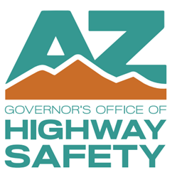Arizona Governor’s Office of Highway Safety Final Statement of Accomplishments Report (October 1, 2024 - September 30, 2025)

**Date:**

**FOR GOHS USE ONLY**

**GOHS Grant Coordinator Initials:**

|  |  |
| --- | --- |
| **Agency Name:** | **GOHS Grant Agreement Number:** |
| **Project Title:** | |

The Project Director shall submit a Final Statement of Accomplishments Report to GOHS **no later than 15 days following the grant agreement end date.** All agencies receiving funding are required to submit this report in addition to their number of active grant agreement quarters (maximum of four (4) quarterly reports). The report is a summary overview of the granted project and is reviewed by GOHS. Please answer the following questions:

No

Yes

Were the Project Measure Goals (see page #3) outlined in the grant agreement achieved? Provide a summary of accomplishments and/or challenges for each goal outlined.

How effective was the funded project in reducing or eliminating the identified traffic safety problem described on the proposal?

(If 100% of the funding was not expended, provide a detailed explanation).

%

What percentage of the awarded funding was expended?

No

Yes

Were the Project Measure Objectives (see page #3) outlined in the grant agreement achieved? Provide a summary of accomplishments and/or challenges for each one.

# Project Administrator

Printed Name: Position:

Signature: Date:

Email Address: Phone:

# Project Director

Printed Name: Position:

Signature: Date:

Email Address: Phone: