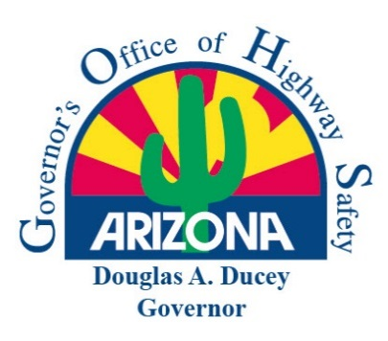
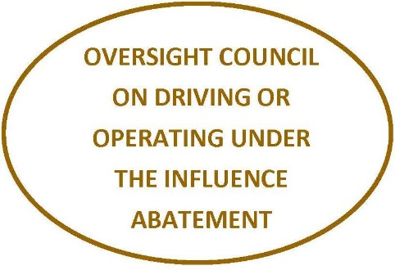

DOUGLAS A. DUCEY
Governor

ALBERTO GUTIER
Director
Governor’s Highway Safety Representative

Vickie Hill
CHAIRMAN
DUI ABATEMENT COUNCIL

DUI Abatement Council Proposal Template

Please use the following template to create your DUI Abatement Council Proposal.

(Agency Name)
(Proposal Title)

The DUI Abatement Council provides State grant funding under two specific areas:

Enforcement:

The council shall make grants from the driving under the influence abatement fund established by A.R.S. 28-1304 to political subdivisions and tribal governments that apply for monies for enforcement purposes, prosecutorial and judicial activities and alcohol abuse treatment services related to preventing and abating driving or operating under the influence occurrences in a motor vehicle or a motorized watercraft as defined in section 5-301.

Innovative:

The council shall make grants from the driving under the influence abatement fund established by A.R.S. 28-1304 to innovative programs that use emerging technologies to educate, prevent or deter occurrences of driving or operating under the influence in a motor vehicle or a motorized watercraft.

Contact Information

Agency: | Agency Name:
 | Address:
 | City, State, Zip:
 | Phone:
Governmental Unit: | Governmental Name:
 | Address
 | City, State, Zip:
Project Director: | Name:
 | Title:
 | Phone:
 | Email:
Project Administrator: | Name:
 | Title:
 | Phone:
 | Email:
Financial Contact: | Name:
 | Title:
 | Phone:
 | Email:

Please attach a cover letter addressed to the Chairman of the DUI Abatement Council on agency letterhead. This cover letter must be signed by a representative of your agency authorized to commit your agency to conduct the grant it be approved for funding.
Traffic Data Summary – Law Enforcement Report
(Submitted to GOHS)

Please include the following traffic data to support the identified problem in your proposal.

DESCRIPTION | 2018 | 2017 | 2016
Total Contacts (Traffic Stops)
Total Traffic Fatalities
Total Sober Designated Drivers Contacted
Total DUI Arrests
Total DUI Aggravated
Total DUI Misdemeanor
Total DUI Extreme (.15 or Above)
Under 21 DUI Arrests
Average BAC
Minor Consumption / Possession Citations
Total DUI Drug Arrests
30-Day Vehicle Impounds
Seat Belt Citations
Child Restraint Citations
Criminal Speed Citations
Aggressive Driving Citations
Civil Speed Citations
Other Citations
Other Arrests
Participating Officer/Deputies (Cumulative)
Total Know Your Limit Contacts

Proposal Summary

Please include a summary of funding requested.

EXAMPLE: Agency requests funding for DUI Overtime Enforcement throughout the city/county of ______________. The Agency plans on using grant funding for extra DUI enforcement saturation patrols during times when impaired driving may be at its highest.

Agency Background

Provide description of agency and work area including information on population and demographics. Also include a description of streets and highways in the agency’s jurisdiction including road mileage.

Problem Statement

What problem is your agency looking to solve with this grant?

Provide appropriate data to support funding for the problem area identified.

Project Objectives / Method of Procedure

Project objectives in your proposal should follow the SMART method. They should be:

S = Specific
M = Measurable
A = Action-Oriented
R = Realistic
T = Time-Framed

State the project objectives in measurable terms that relate to the identified problem. Please detail how your agency will accomplish these objectives over the grant contract period.

DUI Abatement Grant
Estimated Budget Costs

Follow the template provided in the sample budget below for contract expenditures.

Budget Item | Description | Total
Personnel Services (Overtime) |  | $0.00
Employee Related Expenses |  | $0.00
Materials and Supplies |  | $0.00
Capital Outlay |  | $0.00
Total Estimated Cost: |  | $0.00

Budget Narrative

Include a narrative explanation and justification for each budget category expense outlined in the budget costs.

Examples:

Personnel Services & Employee Related Expenses:

Funds will be used for Personnel Services (Overtime) and Employee Related Expenses (ERE) to support and enhance DUI enforcement throughout the City/County of ___________________. Based on the receiving agency’s budget, the approximant ERE percentage will be ______%.

Attachments

A resolution from your agency’s board of supervisors or city/town council will be included in this section. Please attach any further documentation in PDF format when submitting your DUI Abatement Council proposal.

