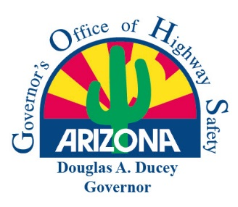 | Arizona Governor’s Office of Highway Safety  Final Statement of Accomplishments Report  FOR GOHS USE ONLY  Date: ____________________ GOHS Grant Coordinator Initials: __________  (October 1, 2021 - September 30, 2022)

Agency Name: | GOHS Contract Number:
Project Title:

The Project Director shall submit a Final Statement of Accomplishments Report to GOHS no later than 15 days following the contract end date. All agencies receiving funding are required to submit this report in addition to their number of active contract quarters (maximum of four (4) quarterly reports). The report is a summary overview of the contracted project and is reviewed by GOHS Project Coordinators. Please answer the following questions:

How effective was the funded project in reducing or eliminating the identified traffic safety problem described on the proposal?

Were the Project Measure Goals (see page #3) outlined in the contract achieved? Yes No
Provide a summary of accomplishments and/or challenges for each goal outlined.

Were the Project Measure Objectives (see page #3) outlined in the contract achieved? Yes No
Provide a summary of accomplishments and/or challenges for each one.

What percentage of the awarded funding was expended? %
(If 100% of the funding was not expended, provide a detailed explanation).

Project Administrator

Printed Name: Position:

Signature: Date:

Email Address: Phone:

Project Director

Printed Name: Position:

Signature: Date:

Email Address: Phone:

