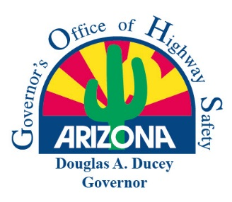 | Arizona Governor’s Office of Highway Safety  Final Statement of Accomplishments Report  FOR GOHS USE ONLY  Date: ____________________ GOHS Grant Coordinator Initials: __________

Agency Name: | GOHS Contract Number:
Project Title:

The Project Director shall submit a Final Statement of Accomplishments Report to GOHS no later than 30 days following the contract end date. All agencies receiving funding are required to submit this report in addition to their number of active contract quarters (maximum of four (4) quarterly reports). The report is a summary overview of the contracted project and is reviewed by the GOHS Project Coordinator. Please answer the following questions:

How effective was the funded project in reducing or eliminating the identified traffic safety problem?

Were the goals and objectives outlined in the contract achieved?
Yes No (Provide a detailed explanation)

What percentage of the awarded funding was expended? %
(If 100% of the funding was not expended, provide a detailed explanation).

What positive accomplishments or obstacles/deficiencies did the grantee face in pursuit of their respective goals and objectives?

Will the project be continued in the future?

Total Contracted Funding:

Total Funding Balance:

Project Administrator

Printed Name: Position:

Signature: Date:

Email Address: Phone:

Project Director

Printed Name: ___ Position:

Signature: _____ ______ Date:

Email Address: ______ Phone:

